**Sgt Lou Savelli, NYPD – retired**

Instructor, Midwest Counterdrug Training Center (MCTC)

**COURSES TAUGHT:**: Physical Surveillance, Advanced Physical Surveillance, Transnational Gangs, Advanced Transnational Gangs, Tactical Debriefing Method

**COURSE TITLE:**

***You Can’t Win a Gunfight You Don’t Know You are In: Recognizing Armed Suspects and Seizing Illegal Firearms in the Streets***

**DESCRIPTION:**

The wide use of body cameras has shown, increasingly, that law enforcement officers possess inadequate knowledge and less than proficient abilities to recognize the characteristics of armed suspects. In this dynamic, exciting and fun training event, officers will learn how to better identify the many characteristics (over 100) of Armed Suspects, such as transnational gang members, drug traffickers, terrorists, and other criminals. Attendees will be instructed how to identify all types of armed drug suspects, the hiding places of drug suspect’s firearms in vehicles, on the street, at drug prone locations, and with the use of devices. Attendees will learn why they should…

* Never Make a Traffic Stop
* Never Tell a Suspect, “Show me your hands!”
* Never Pat Down a Suspect
* Never Search a Suspect or an Arrestee for a Gun

The law enforcement officers who attend this training event will learn how to conduct safer contacts and searches of suspects, recognize otherwise overlooked signs of armed suspects and the presence of firearms, and ultimately increase their ability to be safer and seize more illegal firearms.

**INSTRUCTOR**:

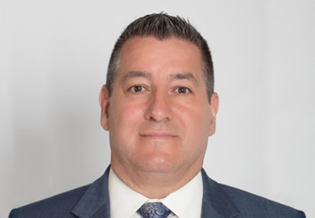

Sgt Lou Savelli retired from the NYPD as the Detective Supervisor of the NYPD Terrorism Interdiction Unit which was responsible for the proactive investigation into the attacks of the World Trade Center on September 11, 2001. He created NYPD’s first citywide gang unit which was awarded the National Gang Crime Research Center’s coveted award for The Most Effective Gang Unit in the United States. He was chosen by former NYPD Police Commissioner William Bratton as one of the top 10 of NYPD's most effective leaders of all ranks (out of nearly 20,000 qualified supervisors in the NYPD) and the first supervisor featured in NYPD's Leadership Training School Newsletter because of his innovation and success in the field of crime-fighting, leadership and policing.

He has seized hundreds of millions of dollars in cash, several tons of drugs and thousands of illegal firearms during his career. In fact, he held the record for the largest seizure in a drug case, $20 Million, in world history until it was broken by Mexican Police Officials in 2007. Lou Savelli is the nation’s leading expert on recognizing the characteristics of armed suspects and has instructed thousands of law enforcement officers on his methods for seizing more firearms in the streets.

Lou Savelli is an instructor for the Midwest Counterdrug Training Center (MCTC) located at Camp Dodge in Johnston, Iowa, where he regularly instructs training classes, such as Physical Surveillance, Transnational Gangs and Tactical Debriefing Method. Lou can be reached at [info@homefrontprotect.com](mailto:info@homefrontprotect.com)