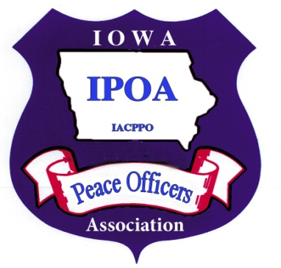

***Iowa Peace Officers Association***

***P.O. Box 100 Denver, Iowa 50622***

**President**

**IOWA PEACE OFFICERS ASSOCIATION**

**2023 RESOLUTIONS**

1. The IPOA supports eliminating the sunset on MVE officer authority permanently, giving them the same authority as all other certified peace officers in the State of Iowa.

2. The IPOA supports increasing retirement rate maximum percentages and other benefit changes to ensure public safety system members are properly compensated for their years of service.

3. The IPOA supports legislation to bring parity in coverage for work related disabilities between the different systems.

4. The IPOA supports legislation requiring blood to be drawn for all motor vehicle fatalities.

5. The IPOA supports legislation allowing law enforcement officers to use accrued sick leave to pay for health insurance premiums upon retirement (SLIP).

**Capt. Mike McKelvey**

Mason City Police Department

641-421-3648

mmckelvey@masoncity.net

**Vice President**

**Chief Marty Duffus**

Osceola Police Department

mduffus@osceolaia.net

**Past President**

**Chief David Lorenzen**

Iowa Motor Vehicle Enforcement

david.lorenzen@iowadot.us

**Secretary/Treasurer**

Terry Dehmlow

319-269-4104

iacop2@mchsi.com

**Legislative Consultant**

Kellie Paschke

515-991-5205

kellie@splawiowa.com

**BOARD MEMBERS**

**Sgt. Augustin Farmer**

Waterloo Police Department

farmera@waterloopolice.com

**Officer Dean Sharp**

Council Bluffs Police Department

dks657@cox.net

**Officer Steve Jacobs**

Council Bluffs Police Department

[sjacobs13435@gmail.com](mailto:sjacobs13435@gmail.com)

**Sgt. Glenn Goode**

Iowa Motor Vehicle Enforcement

Glenn.goode@iowadot.us

**Chief David Niedert**

Independence Police Department

chief@indytel.com